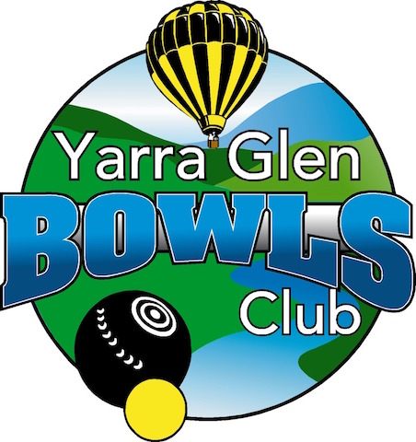
YARRA GLEN BOWLS CLUB INC
(Inc. No. A0005294M ABN 59442281102)
Anzac Avenue Yarra Glen 3775
Phone 9730 1718
PO Box 383, Yarra Glen, VIC 3775
yarraglenbowlsclub@gmail.com

Application for membership

We hereby nominate (full name) MR/ MRS/ MS/ MISS___________________________________________
Proposer: __________________________________ Seconder: ___________________________________
PRINT PRINT
__________________________________ ____________________________________
SIGN SIGN
------------------------------------------------------------------------------------------------------------------------------------------------------------
PERSONAL DETAILS:
Address: __________________________________________________________________________________
P/Code: _______________________________ Date of birth: ___________________________
Postal Address: _____________________________________________________________________________
P/Code: _______________________________ Telephone: _____________________________
Mobile: _______________________________ Email: _________________________________
Are you currently a member of a Bowls Club? YES / NO
If YES, please advise which club. _____________________________________ State: _____________________
If you have been a member of another Bowls Club within the last 5 years, you will need a clearance from that club.
Are you a qualified coach? YES / NO Year of renewal: ________________ Reg. No: __________________
Are you a qualified umpire? YES / NO Year of renewal: ________________ Reg. No: _________________
Do you have any other relevant qualifications, such as Working with Children, First Aid?
__________________________________________________________________________________________
Emergency contact name: _______________________________ Telephone: ___________________________
If you are applying for full membership, you should be aware that this Club depends on volunteers to keep the running of and membership fees to a minimum. By applying for membership you are bound by the Constitution and By-Laws of the Club as well as agreeing to assist with work around the Club from time to time.
Applicants signature: _______________________________ Date: ___________________________________
This information will be treated strictly confidential in accordance with the Privacy Act.

